IN THE CIRCUIT COURT FOR THE 15TH JUDICIAL CIRCUIT
STEPHENSON COUNTY – FREEPORT, ILLINOIS

DITECH FINANCIAL LLC
Plaintiff, | Case No. 18 CH 5
vs.
vs. | Property Address:  317 W. Roosevelt St.  Freeport, IL 61032
JASON M. ALBRIGHT; SUSAN E. ALBRIGHT A/K/A SUSAN E. OTTENHAUSEN; BANK OF AMERICA, N.A.; MIDLAND FUNDING, LLC; JEFFERSON CAPITAL SYSTEMS, LLC; PORTFOLIO RECOVERY ASSOCIATES LLC; UNKNOWN OWNERS AND NON-RECORD CLAIMANTS
Defendant(s).

NOTICE OF FILING

TO: See Attached Service List
PLEASE TAKE NOTICE that on __________________, our office filed with Clerk of the Circuit Court of
Stephenson County our Appearance and Answer, a copy of which is attached hereto and served upon you.
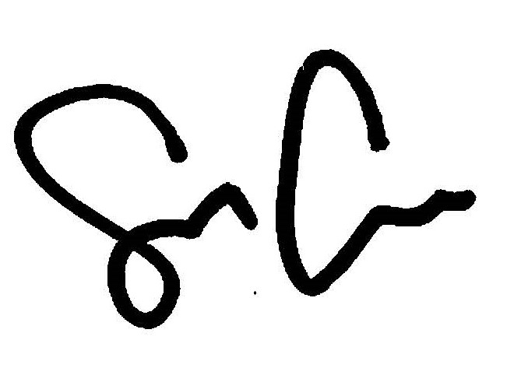
By: ___________________________________
Shaun Callahan
Attorney, Marinosci Law Group, P.C.
ARDC No.: 6296022

CERTIFICATE OF SERVICE

I, Shaun Callahan, hereby certify under penalty of perjury and 735 ILCS Sec. 1-109, that I caused to be served on the members of the attached service list, the attached document, by mailing a copy via US Mail, postage pre-paid at 134 N. LaSalle St., Chicago, Illinois, 60602, or alternatively by electronic mail as so noted on ________________, before the hour of 5:00 p.m.
By: ___________________________________
Shaun Callahan
Attorney, Marinosci Law Group, P.C.
ARDC No.: 6296022

MARINOSCI LAW GROUP, P.C.
134 N. LaSalle Street, Suite 1900
Chicago, IL 60602
Telephone: 312-940-8580
Fax: 401-234-5130
mlgil@mlg-defaultlaw.com

SERVICE LIST

CODILIS & ASSOCIATES, P.C.
Via electronic mail to: pleadings@il.cslegal.com

IN THE CIRCUIT COURT FOR THE 15TH JUDICIAL CIRCUIT
STEPHENSON COUNTY – FREEPORT, ILLINOIS

DITECH FINANCIAL LLC
Plaintiff, | Case No. 18 CH 5
vs.
vs. | Property Address:  317 W. Roosevelt St.  Freeport, IL 61032
JASON M. ALBRIGHT; SUSAN E. ALBRIGHT A/K/A SUSAN E. OTTENHAUSEN; BANK OF AMERICA, N.A.; MIDLAND FUNDING, LLC; JEFFERSON CAPITAL SYSTEMS, LLC; PORTFOLIO RECOVERY ASSOCIATES LLC; UNKNOWN OWNERS AND NON-RECORD CLAIMANTS
Defendant(s).

APPEARANCE

I, the undersigned hereby enter my appearance on behalf of Defendant: BANK OF AMERICA, N.A.

By: ___________________________________
Shaun Callahan
Attorney, Marinosci Law Group, P.C.
ARDC No.: 6296022

MARINOSCI LAW GROUP, P.C.
134 N. LaSalle Street, Suite 1900
Chicago, IL 60602
Telephone: 312-940-8580
Fax: 401-234-5130
mlgil@mlg-defaultlaw.com

IN THE CIRCUIT COURT FOR THE 15TH JUDICIAL CIRCUIT
STEPHENSON COUNTY – FREEPORT, ILLINOIS

DITECH FINANCIAL LLC
Plaintiff, | Case No. 18 CH 5
vs.
vs. | Property Address:  317 W. Roosevelt St.  Freeport, IL 61032
JASON M. ALBRIGHT; SUSAN E. ALBRIGHT A/K/A SUSAN E. OTTENHAUSEN; BANK OF AMERICA, N.A.; MIDLAND FUNDING, LLC; JEFFERSON CAPITAL SYSTEMS, LLC; PORTFOLIO RECOVERY ASSOCIATES LLC; UNKNOWN OWNERS AND NON-RECORD CLAIMANTS
Defendant(s).

ANSWER TO COMPLAINT TO FORECLOSE MORTGAGE

NOW COMES Defendant, BANK OF AMERICA, N.A., by and through its attorneys, MARINOSCI LAW GROUP, P.C. and in answer to the Complaint in the above-captioned case states as follows:
1. Defendant admits the allegations in paragraph 1.
2. Defendant neither admits nor denies paragraph 2, since it has insufficient knowledge to form a belief as to the truth thereof, but demand strict proof of same.
3. Defendant neither admits nor denies paragraph 3, subparagraphs (A), (B), (C), (D), (E), (F), (G), (H), (I), (J), (K) since it has insufficient knowledge to form a belief as to the truth thereof, but demands strict proof of same.
4. Defendant admits the allegations in paragraph 3, subparagraph (L), furthermore, attached as Exhibit A to its Answer is a true and correct copy of its recorded Mortgage. Said mortgage is a valid second lien on the subject premises, subordinate only to the first lien held by DITECH FINANCIAL LLC.
5. Defendant neither admits nor denies paragraph 3 subparagraphs (M), (N), (O), (P), (Q), (R), (S), (T) since it has insufficient knowledge to form a belief as to the truth thereof, but demands strict proof of same.
6. Defendant neither admits nor denies paragraph 4, since it has insufficient knowledge to form a belief as to the truth thereof, but demand strict proof of same.

WHEREFORE, Defendant, BANK OF AMERICA, N.A., prays that this Court:
- Find that Defendant has a valid and enforceable lien on the subject property, subordinate only to that of Plaintiff;
- Include Defendant’s interest in any judgment of foreclosure and sale entered herein;
- Allow Defendant to offset its debt against its bid in the event that Defendant bids at judicial sale;
- Grant any further relief the Court deems just and equitable.

Respectfully submitted,

By: ___________________________________
Shaun Callahan
Attorney, Marinosci Law Group, P.C.
ARDC No.: 6296022

MARINOSCI LAW GROUP, P.C.
134 N. LaSalle Street, Suite 1900
Chicago, IL 60602
Telephone: 312-940-8580
Fax: 401-234-5130
mlgil@mlg-defaultlaw.com

